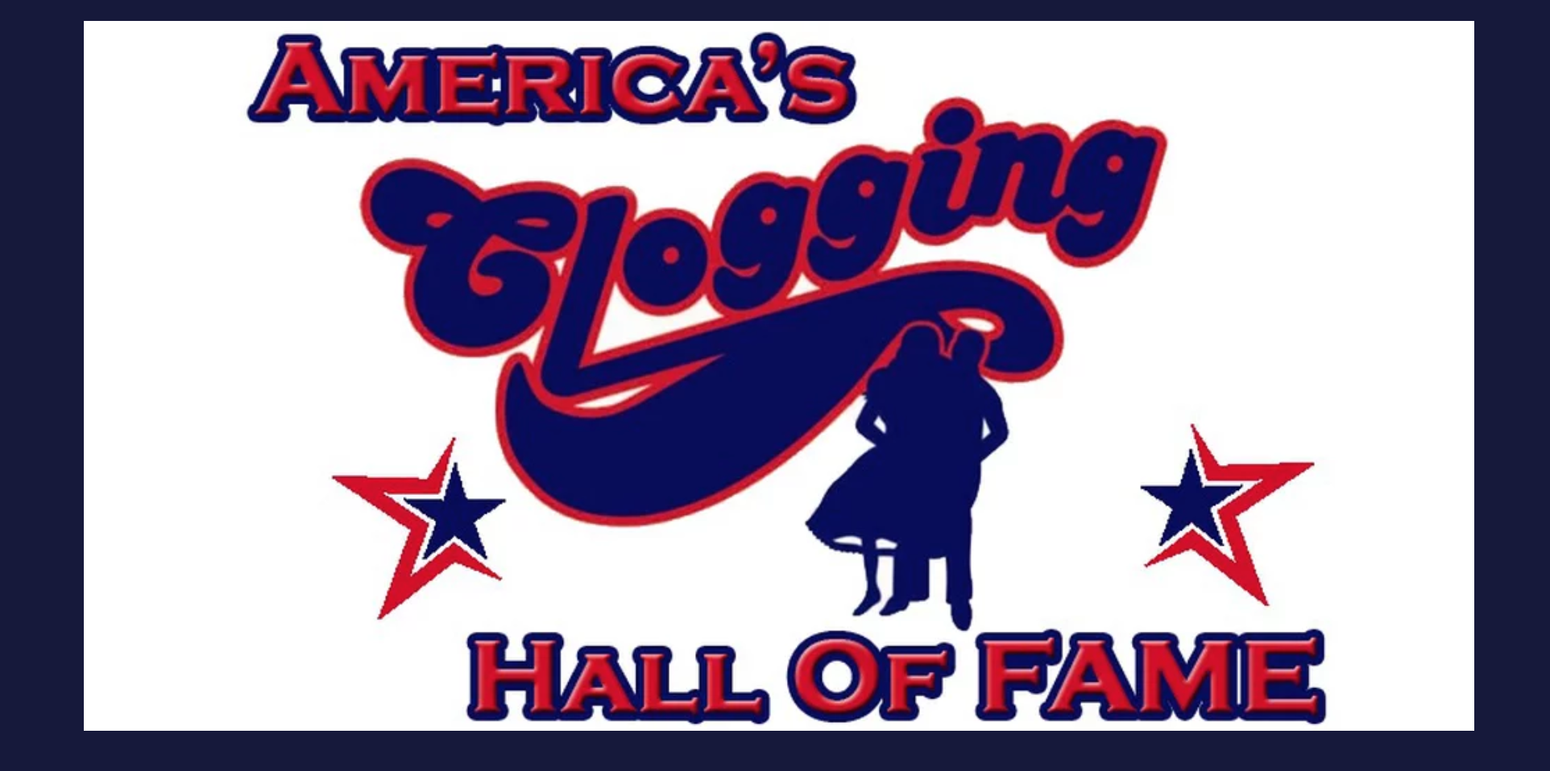

February 2018

Greetings Directors, Parents and Cloggers!

The ACHF board understands that there has been some confusion going around about what has happened to America’s Clogging Hall of Fame. We would like to take a moment to clear up any confusion and help you to understand that we are the same organization but are now incorporated as a legal entity. America’s Clogging Hall of Fame being formed by Dan & Sandy Angel in 1981, was once formed as a non-profit organization with a tax id. Through the years and changing in leadership this number has never been used and there has never been an audit or the transparency that was owed to its members. Henry Jones, President of ACHF along with board members, voted for Henry to take the steps necessary to correct the situation so that this organization was not associated with any one person’s social security number and never will be again. The organization now has a legal tax id number and all money for this organization is in an account under that tax id number with America’s Clogging Hall of Fame listed on the account.

ACHF needed to have a home base address to be incorporated, which is listed under Vice-President, Elliott Skeen’s address to keep the organization based in the state of North Carolina. This LLC listing allows us to be recognized by the state as a non-profit organization. This non-profit status will open many doors for us to grow as a clogging community. Currently we are now in the process of filing for a 501(c)3 status and the lawyer taking care of this amended our bylaws to remove the wording of “memberships” so we would qualify. We are hoping that with this tax status we will be able to receive donations from outside corporations to make our competitions and workshops better than ever and hopefully help keep competition costs down in the future.

Membership status will be handled differently with the organization. You are a member based on your participation with competitions and workshops. There are no more membership fees and voting will be handled by the board. The board is made up of a balance of traditional and contemporary directors. We feel that by doing this gives each group a voice. We want each of you to feel that you can call us, approach us and talk at any time. We are here to work for you and the betterment of the organization.

The competitions listed on the ACHF.us website are the competitions that are sanctioned with America’s Clogging Hall of Fame. We are not removing any competitions and all are qualifiers for the October Dance off at the end of this season. It is our hope that the directors of these competition qualifiers continue to work with us and strive to make this organization the best it can be.

The reorganization is bringing many new things and opportunities that are coming in the future. We are already working on a great workshop/competition in Gatlinburg, Tennessee for July called, Smokey Mountain Extreme. We have been in contact with many great instructors and will be revealing them a few at a time to build excitement for the clogging community. We are working on a judges training and refresher course for all our judges and reps. We hope this will provide a very knowledgeable selection of judges for future competitions. We are also excited that our National Championships in October will be held this year in Gatlinburg TN, so keep your eyes peeled for what’s to come.

The ACHF board hopes that you are excited of all the opportunities that we are striving to achieve. America’s Clogging Hall of Fame hopes to receive your continued support as we move forward and offer many new exciting features. We appreciate your feedback and ideas to help this organization continue to grow and serve its participants.

Thank you for your time and the opportunity to work with you!

Sincerely,

Henry Jones, President
Elliott Skeen, Vice-President
Heather Vassey, Secretary
Terry Anderson, Treasurer
Quinn Stansell, Public Relations
Rob Pack, At Large Board Member
Sierra Jackson, At Large Board Member

