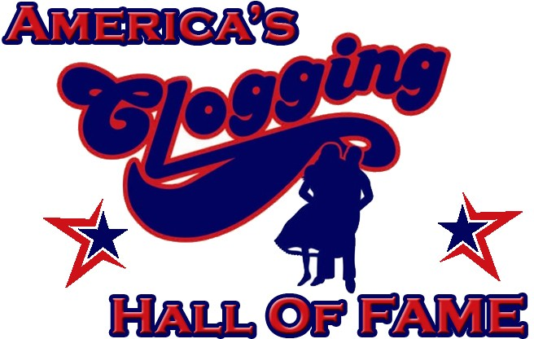
America’s Clogging Hall of Fame Academic Scholarship Requirements

- There must be a real expressed desire by the applicant to continue their education.

- The applicant must be a clogger and may be of any race, color, or national origin.

- The applicant must be able to meet the entrance requirement of the college/university in which they wish to enroll or if already enrolled, they must not be on academic probation or suspension.

- All applicants must be a high school senior, about to enter college, or a current college/university student.

- The applicant must be of good moral character.

- Recipients of the scholarship do not have to be active in America’s Clogging Hall of Fame but it is encouraged.

- Cash will not be given to the recipient. A check will be mailed to the college he or she is enrolled in and their account will be credited.

- The amount of each scholarship award given is decided based on available funds in the scholarship account. Three scholarships are awarded during the America’s Clogging Hall of Fame World Championships each year.

- Applicants being considered and/or receiving America’s Clogging Hall of Fame scholarships must provide scholarship committee additional information, if requested.

- Guidelines for selecting recipients are as followed, but not limited to: student grades and course load, involvement in the clogging community, any honors and/or leadership roles, clogging director recommendation, and overall discretion of the scholarship committee.

2019 Scholarship Committee:
April Straughn – april@sapphire-studio.com - (336) 622-8986
Tayler Gentle – oakcitycloggers@gmail.com – (919) 413-6605 Missy Campbell – uscgrad89@charter.net – (864) 347-6136

Revised: 09/2019

