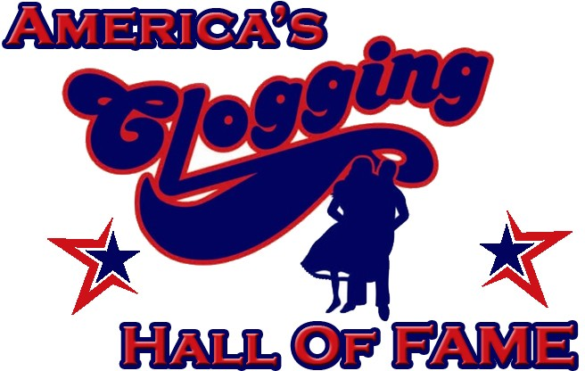
Dedicated to the preservation of Southern Appalachian clogging by honoring past and present leaders of the age-old art of clogging.

Academic Scholarship Application Form
If necessary, please use additional paper. Write legibly.

--------------------------------------------------------------------------------------------
Personal Information:

Name:
(First) (Middle) (Last) (Nickname, if any)

Permanent Address:
(Street or PO Box) (Apt. #)

(City) (State) (Zip)

Email Address:

Phone Number:
(Home) (Cell) (Other)

Date of Birth (MM/DD/YYYY): / / Gender: M F

Parent/Guardian Names:

--------------------------------------------------------------------------------------------
Current Year in School (must circle one below):
High School: 12th College: Freshman Sophomore Junior Senior Other:

--------------------------------------------------------------------------------------------
Work Activity:
Work Type Employer Dates Average # Hours/Week

High School Information: (all applicants MUST submit high school transcripts)
High School Name: Graduated? Y N Address:
GPA: ___________ GPA: ___________ SAT Score: __________ ACT Score: __________ Other: __________________
(weighted) (unweighted)
Dates Attended: / to / Number of Classes: Honors: _____ AP: _____
Month Year Month Year
High School Activities, Awards, Scholarships, Special Recognition, Leadership: Activity Dates Offices

--------------------------------------------------------------------------------------------
College Information: (if over one semester completed, applicant MUST also submit college transcripts)
College Name:

Financial Aid Address: College Major: 2nd Major/Minor: College Credits Earned (to date): Total Credits Needed: GPA: Date Expected to Receive Bachelor’s Degree (month, year):
Career Ambition:

Degree Desired:
________ Associate’s
________ Bachelor’s
________ Master’s
________ Doctorate

College Activities, Awards, Scholarships, Special Recognition, Leadership: Activity Dates Offices

Public Service/Community Service/Government Activities:
Activity Role Dates # Weeks Active

--------------------------------------------------------------------------------------------
Clogging Contributions: Please submit a clogging director recommendation letter (optional, but encouraged)
Years the Applicant has been Involved in Clogging: _________ years
Year Applicant Joined ACHF All American Team: ☐ Junior ☐All American
(if applicable)
Clogging Team Affiliation(s):
Team/Studio Name Dates Active on Team Current Member?

Awards/Individual Honors Received (excludes team competition awards)/Opportunities:

Leadership Roles (including teaching):

Future Goals/Additional Information:

--------------------------------------------------------------------------------------------
Disclosure Statement:
I, (name of applicant) have read and understand the conditions of the ACHF scholarship as explained in the Academic Scholarships Requirements document and ACHF website. I affirm the information contained herein is true and accurate to the best of my knowledge and belief. By signing this statement, I also understand that I must submit a certified copy of my high school and college transcripts (if in college) by the application postmark deadline in order to be selected for the scholarship. Winners will be announced at the ACHF World Championships.

Applicant’s Signature: Date: / /

--------------------------------------------------------------------------------------------
Important Items to Include Upon Submission:

- Completed Application (required)
- Director Letter(s) (optional, but encouraged)
- Certified High School Transcript (required)
- Certified College Transcript (required if in college)

--------------------------------------------------------------------------------------------
Mail Application and Documents to: April Straughn P.O. Box 893, Liberty, NC 27298

--------------------------------------------------------------------------------------------
2019 ACHF Scholarship Committee:
Sierra Jackson – sierra.n.jackson@gmail.com April Straughn – april@sapphire-studio.com - (336) 622-8986
Tayler Gentle – oakcitycloggers@gmail.com – (919) 413-6605 Missy Campbell – uscgrad89@charter.net – (864) 347-6136

--------------------------------------------------------------------------------------------
For ACHF use only:
Date Received _ Reviewed By Date of Follow-up Date Information Needed By _ Additional Information Needed _ Date Approved _ Amount Approved _ Date Check Mailed to College Authorized By _ Witness _

